**About Decision Tree:**

**Any Decision Rule used to Test or Evaluate the Conditions.**

**In Decision Tree we can add Multiple If Conditions ( All are If Conditions ( NO Else IF Conditions in Tree)**

**All conditions are in format of If & Nested If**

**If Decision Tree b/w if conditions OR Logic will apply by default.**

**In Decision Tree there is no Expression Builder.**

**We can Call Decision Tree in Flow  ( Decision Shape), Activity ( Property Map Decision Tree), Declare Expressions ( Result of Decision Tree) & In Decision Tree**

**Working with Decision Tree:**

**Create Commercial Vehicle section using Page list Properties:**

**To Use Page list Properties in section we have to use Repeating /Table Layout.**

**Add a PageList Property to Referring to Vehicle Data Class:**

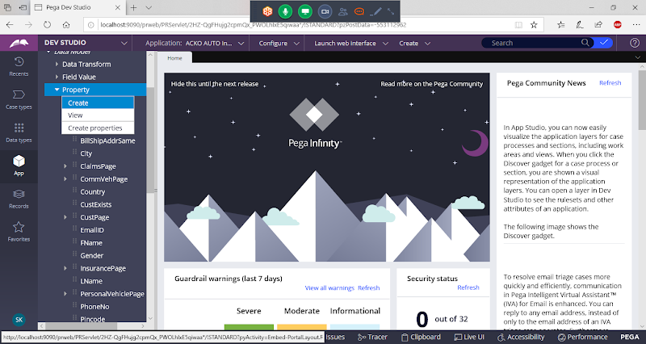

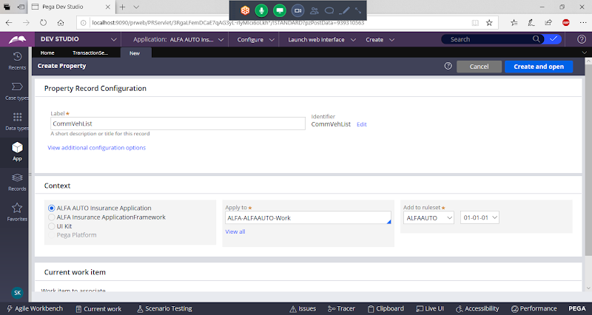

**open**

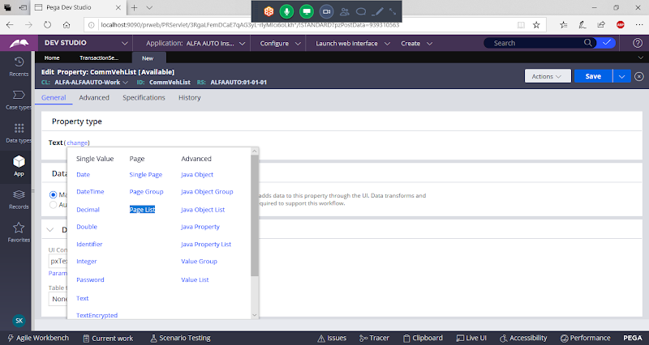

**Select Page list**

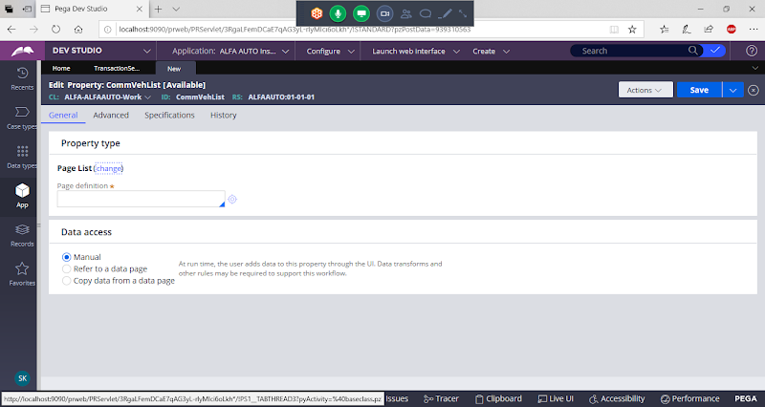

**Give Vehicle Data Class Name under Page Definition**

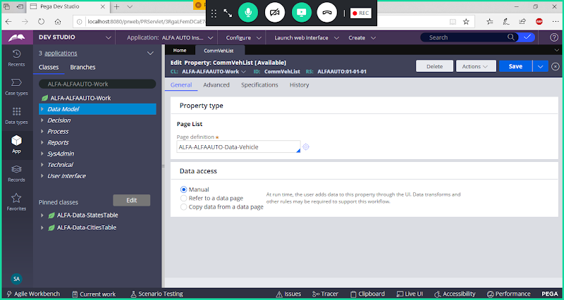

**Save Property**

**Create a Commercial Vehicle Section:**

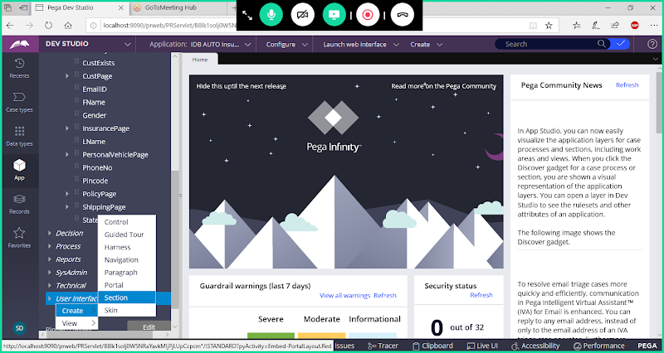

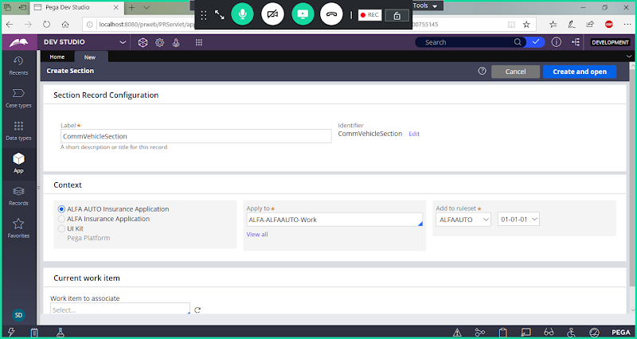

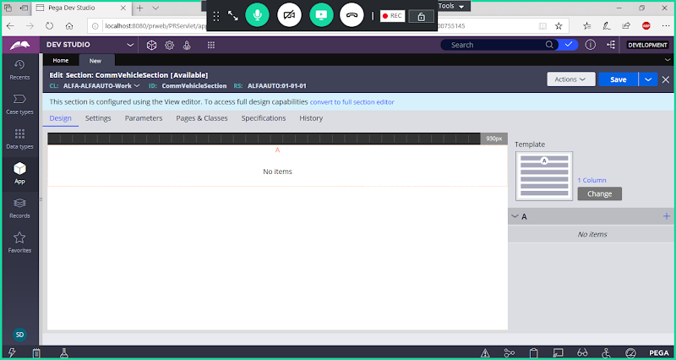

**Convert to full section editor**

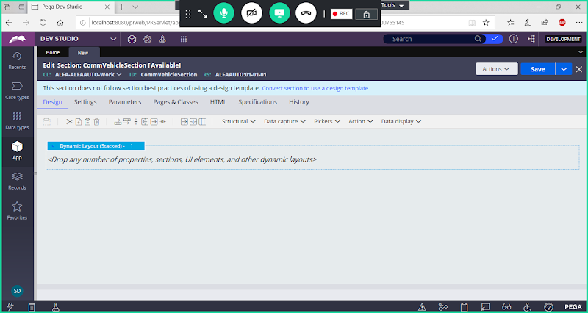

**To Use PageList Properties in section we have to Use Table Layout/Repeating Layout**

**Add Table Layout Outside Dynamic Layout:**

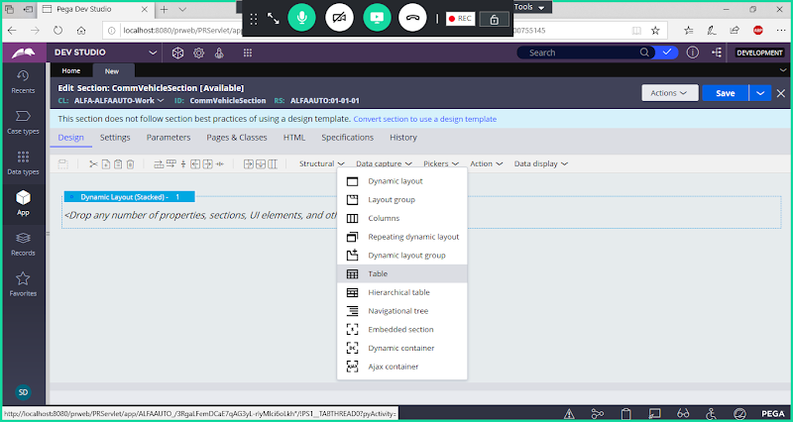

**Drag & Drop Table Layout**

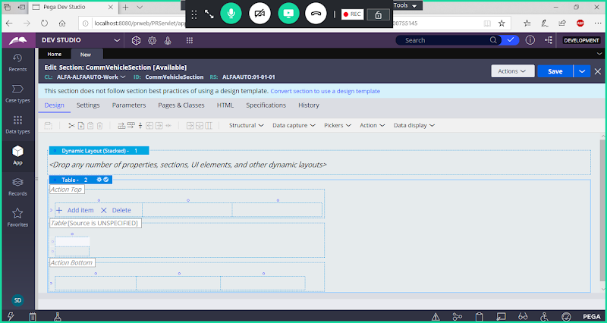

**Delete Dynamic Layout ( Right Click & Delete)**

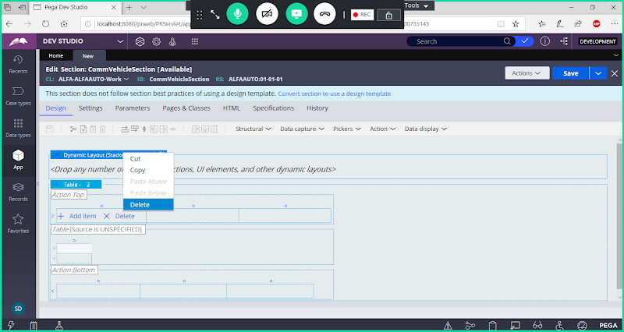

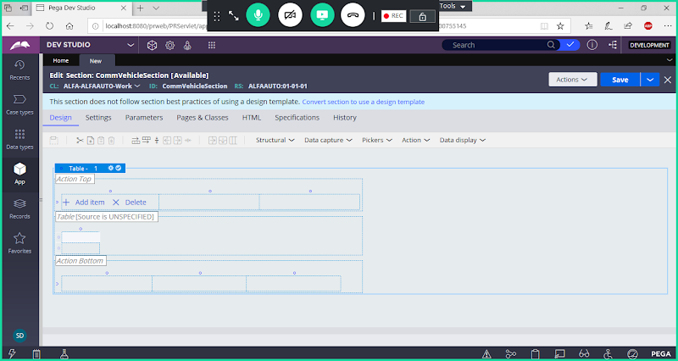

**To  Specify Source Open Layout Settings**

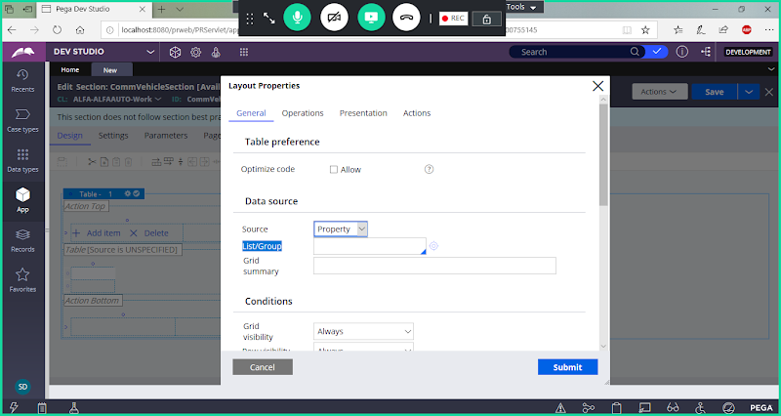

**In List/Group select Page List Property ( CommVehList)**

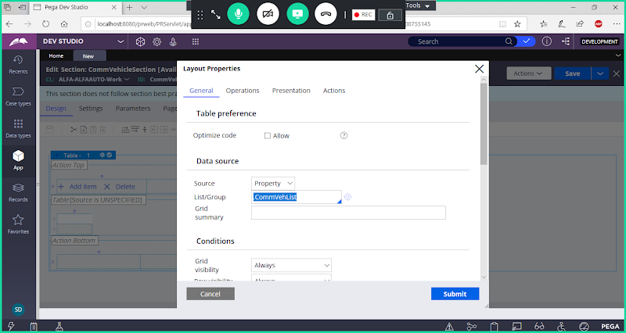

**Now Click on Operations Tab:**

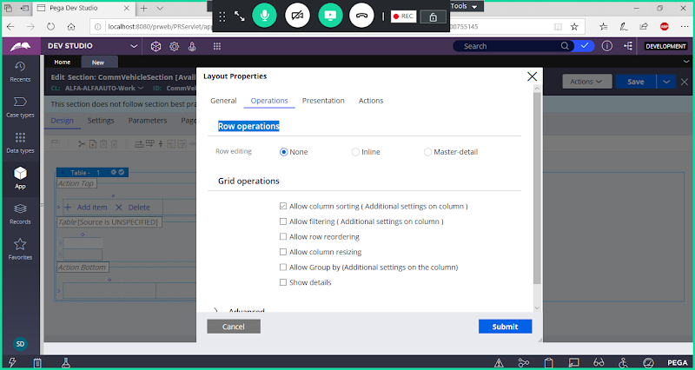

**Under Row Operations-> Row editing ->  Select Inline**

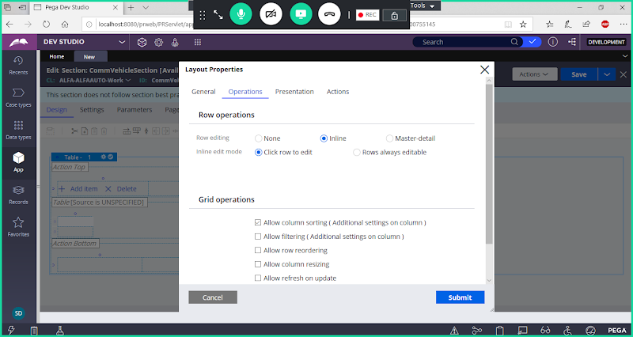

**Click on Submit**

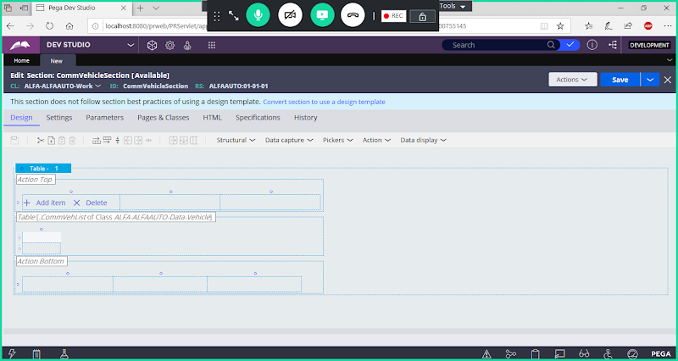

**Add Columns**

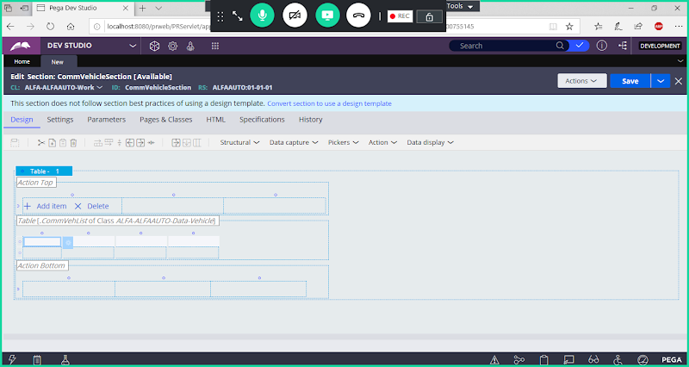

**Drag & Drop CommVehiclePage List Properties**

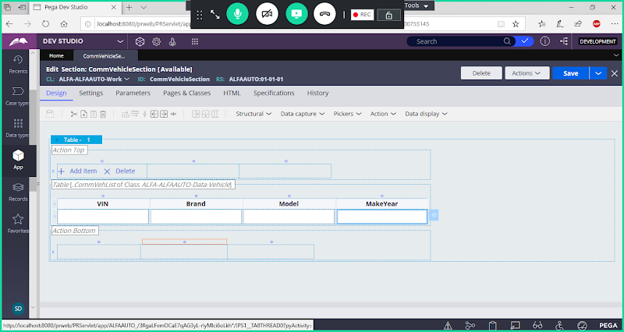

**Save Section**

**Add a Flowaction:**

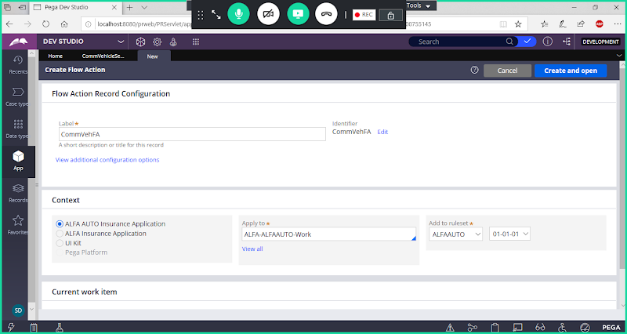

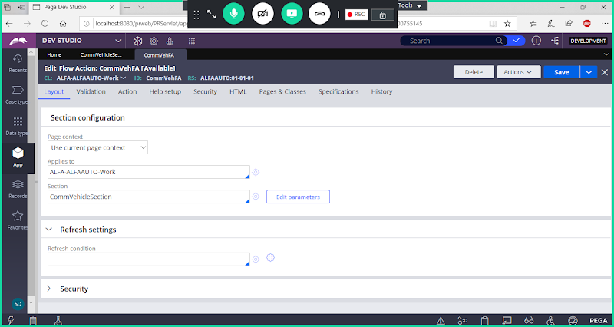

**Save Flowaction**

**Open Insurance Type Property:**

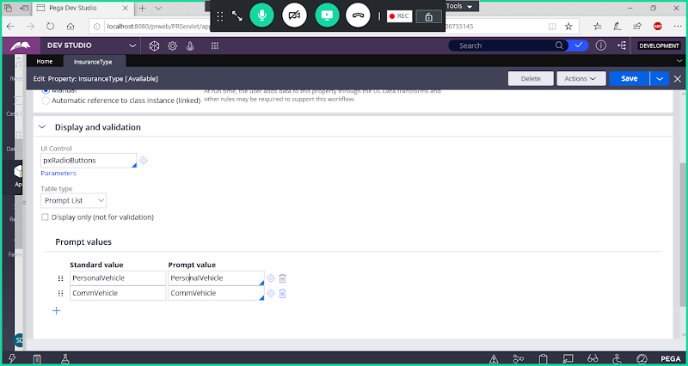

**Update Standard Value with Code Names**

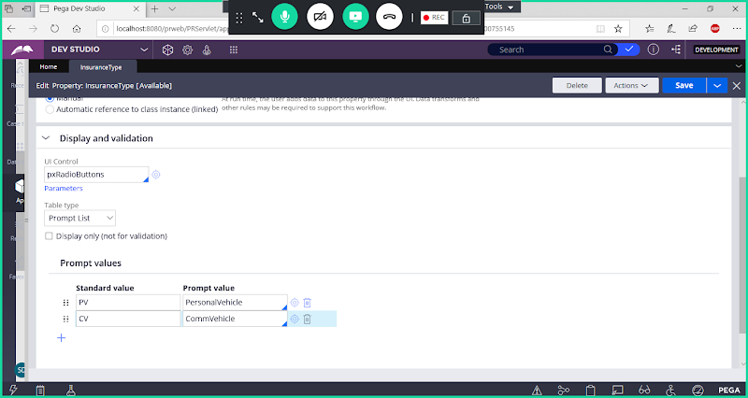

**Save Property**

**Now Add Decision Tree Condition:( If Statements)**

**Req:  In Transaction Form if Insurance Type is selected as PV display Personal Vehicle form. If Type is selected as CV display comm Vehicle Form.**

**Create Decision Tree:**

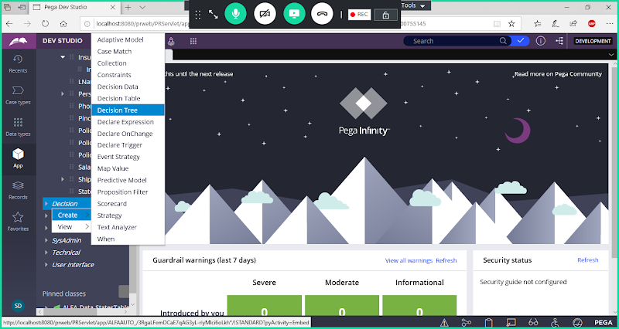

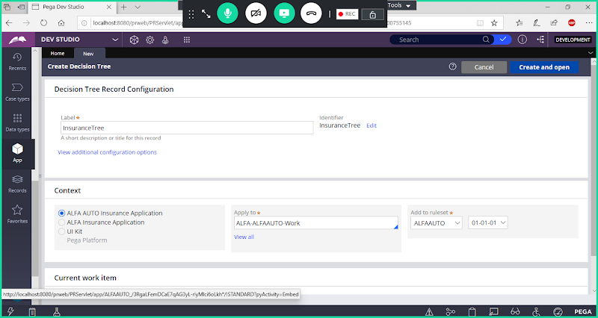

**Open**

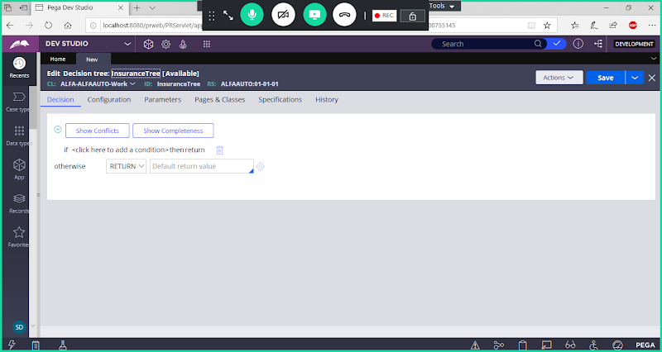

**Double click on Condition**

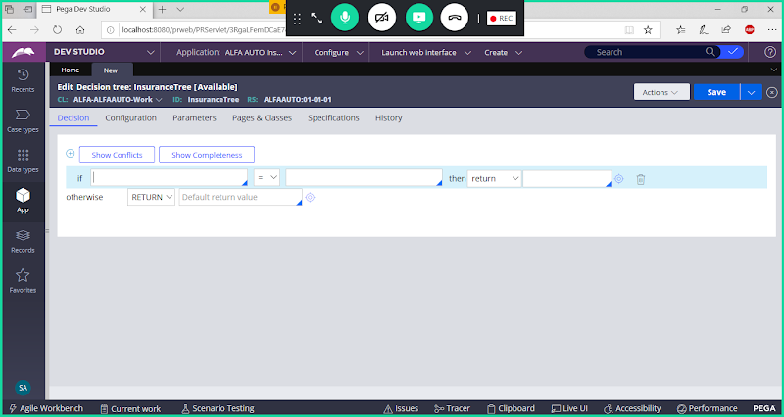

**Now add Property & Results**

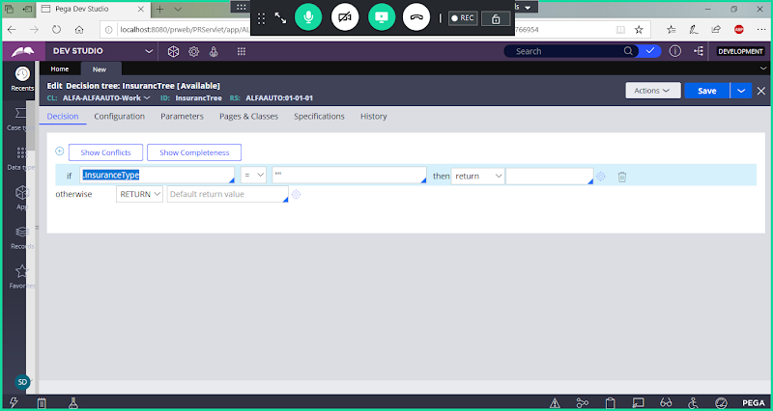

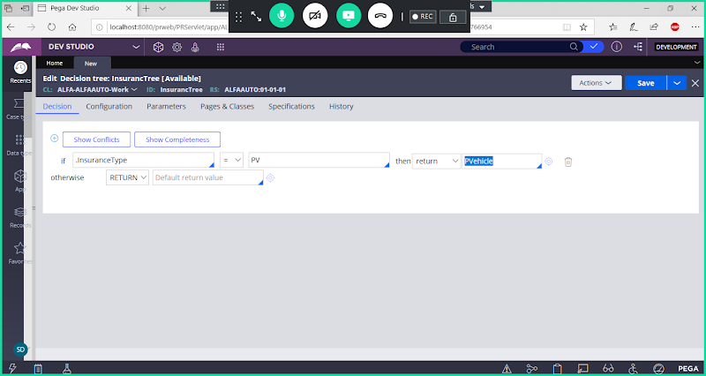

**Add a Row**

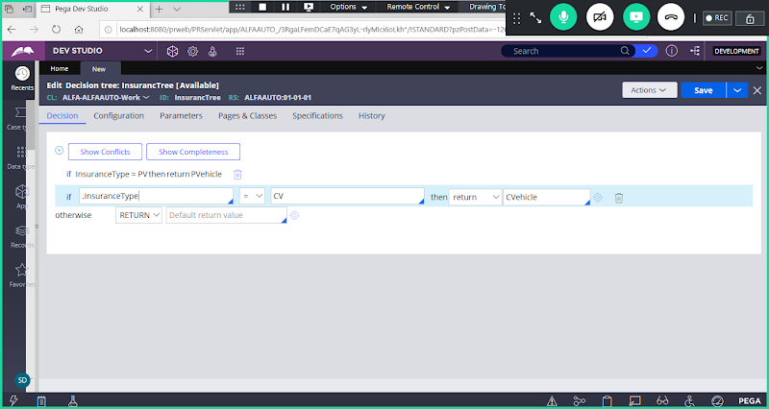

**Add Property & Results**

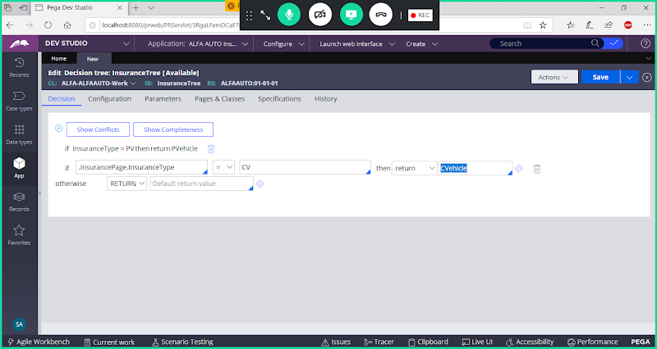

**In Otherwise give any Result**

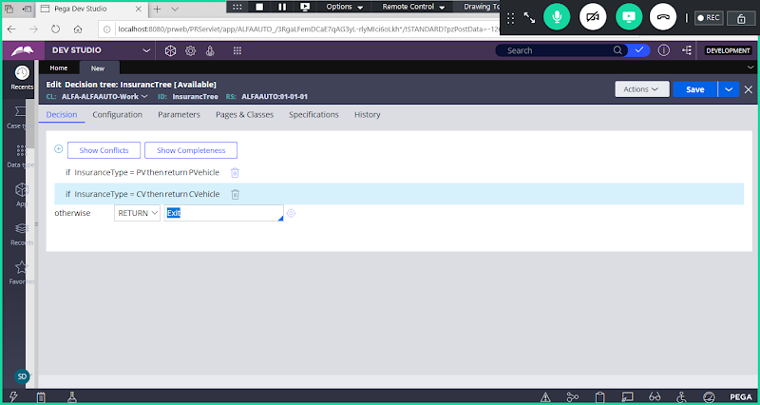

**Save Decision Tree**

**Call Comm Vehicle Flowaction & Decision Tree in Insurance Flow:**

**Open Insurance Flow & Use Save as**

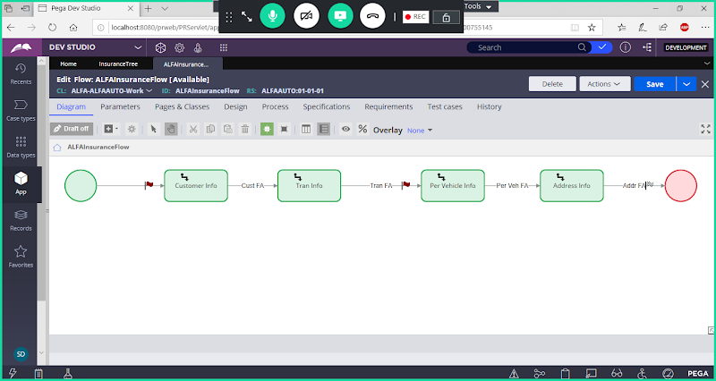

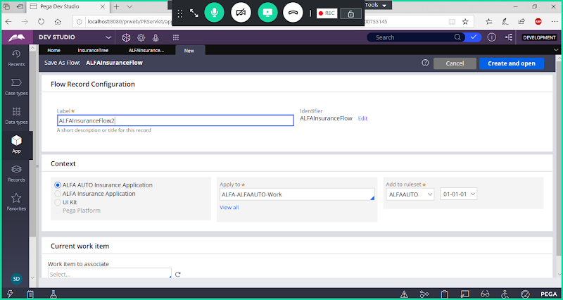

**Adjust Shapes as shown below**

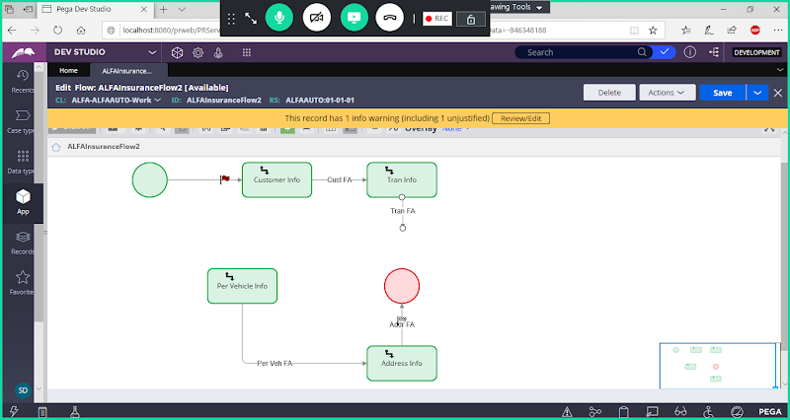

**Add  Decision Shape after Transaction Assignment:**

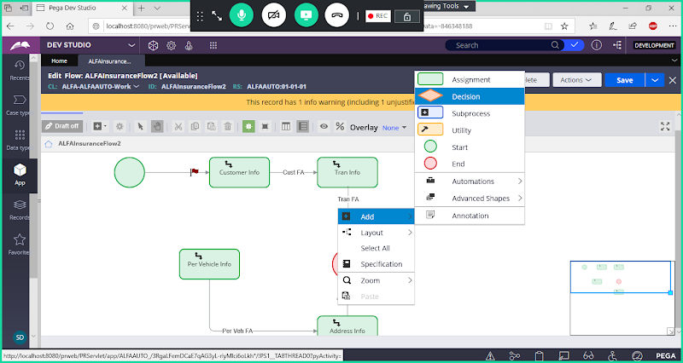

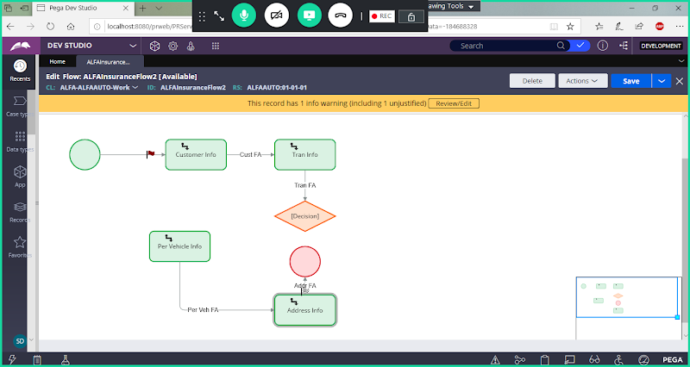

**Call Decision Tree in Decision Shape &  Assign Result/status in Decision Connector Properties**

**Double Click on Decision Shape Properties & Add Decision Tree Condition**

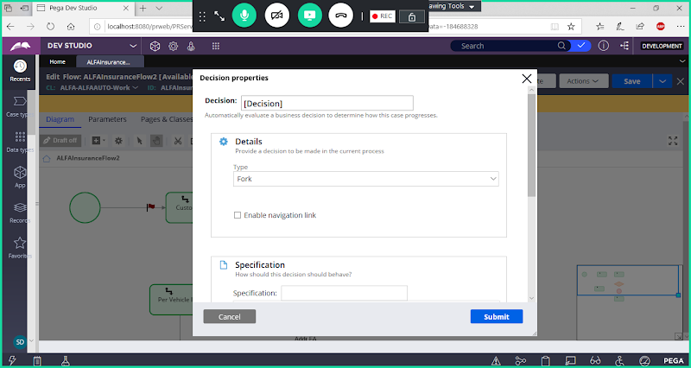

**Select Type: Decision Tree**

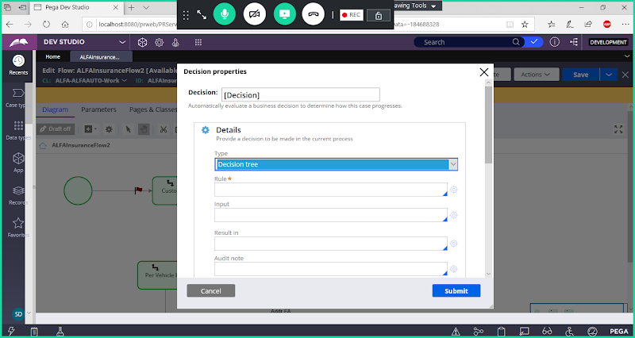

**Select Decision Tree Rule Name**

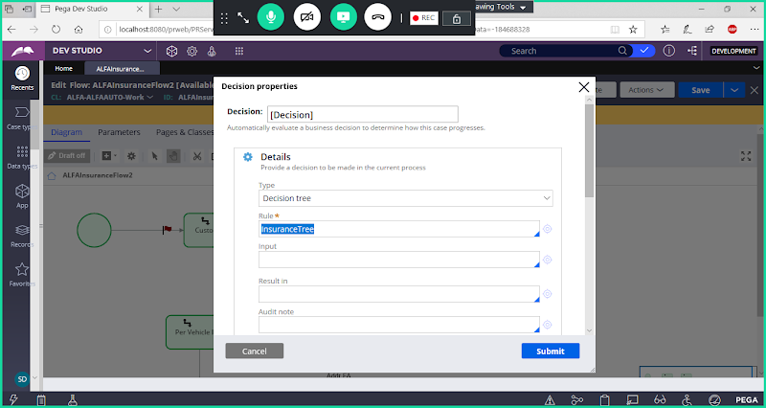

**Submit**

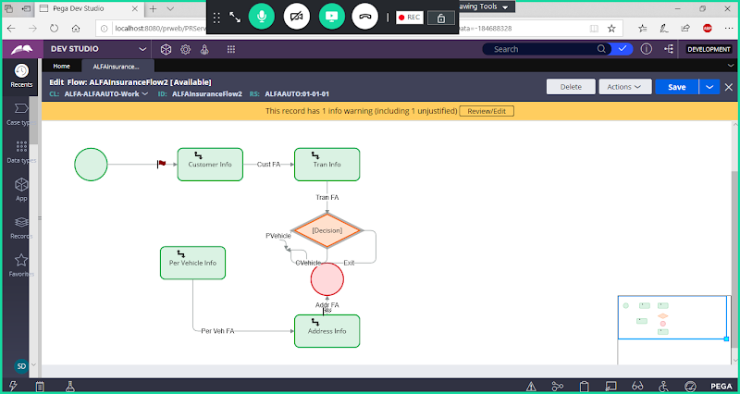

**It will automatically generate connections based on no of Results added in Tree Condition. Now Map Connectors to assignment shape.**

**First Delete  Exit Connector.**

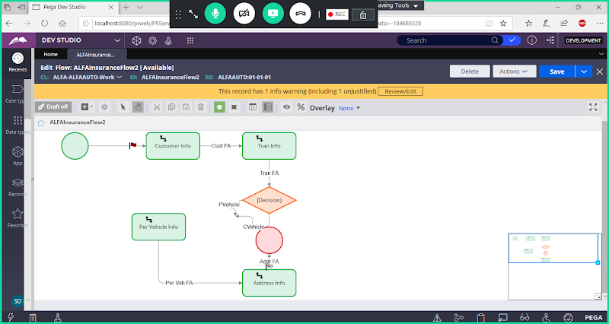

**Now Map PVehicle Connector to Personal Vehicle Assignment.**

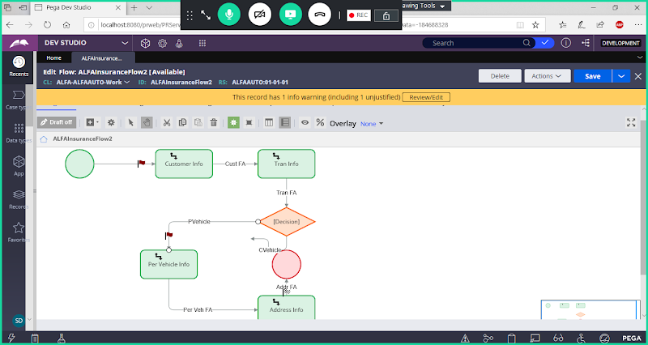

**Now  Add New Assisgnment ( Comm Vehicle) Map CVehicle Connector to Commercial Vehicle Assignment**

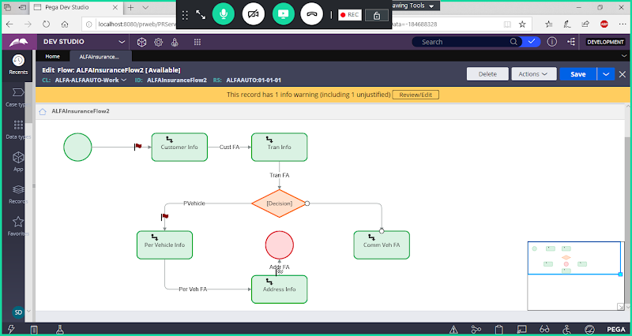

**Now From Commercial Vehicle Assisgnment add Connector towards address assignment**

**Add Commercial Vehicle Flowaction under Commercial Vehicle Connector.**

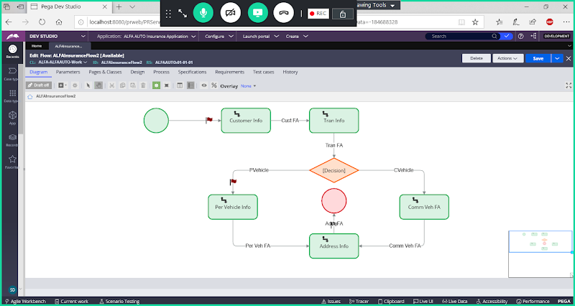

**Now Save Flow . After Saving flow you will get few errors.**

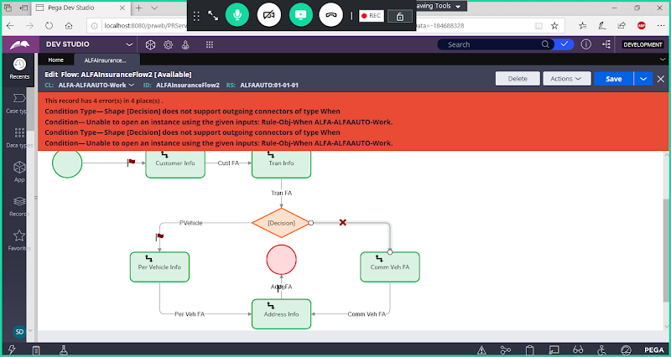

**To Resolve these errors follow below steps:**

**Now Double Click on Decision Shape Result Connectors & Submit. Error will be gone automatically**

**Double Click on PVehicle & Submit**

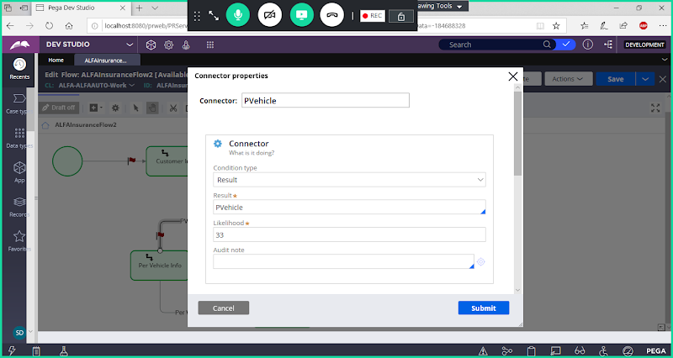

**Double Click on CVehicle**

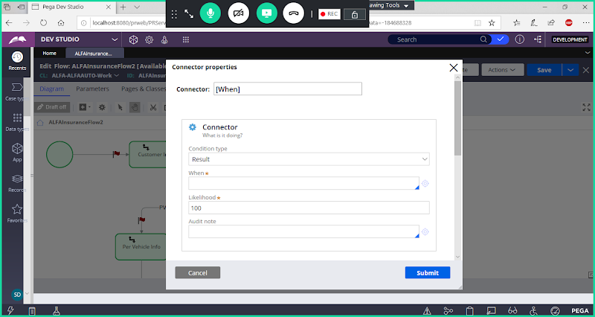

**Give Connector Name & Select Result/When as CVehicle**

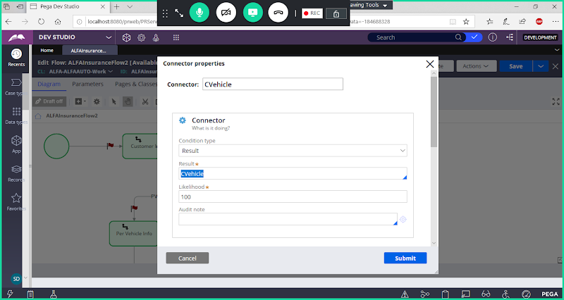

**Submit**

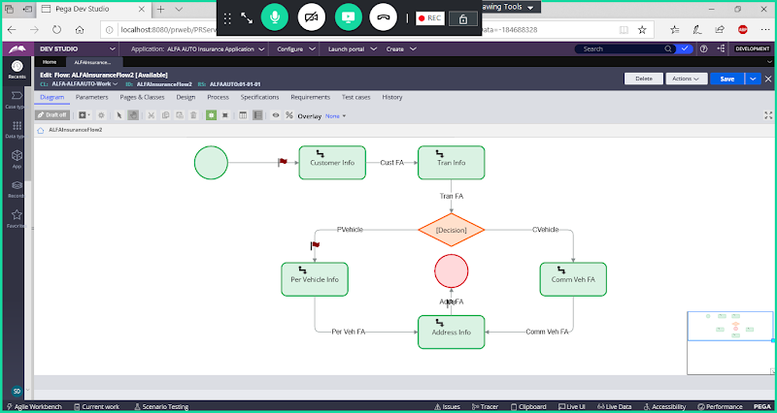

**Now Run Flow**

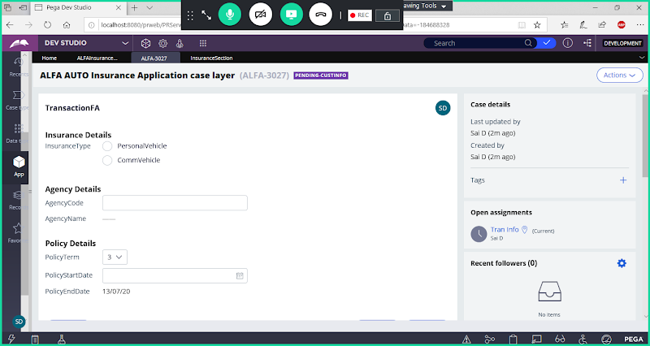

**Select Commercial Vehicle**

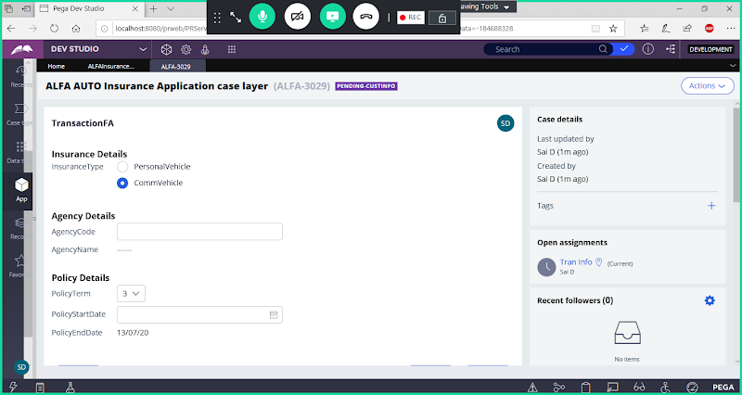

**Submit**

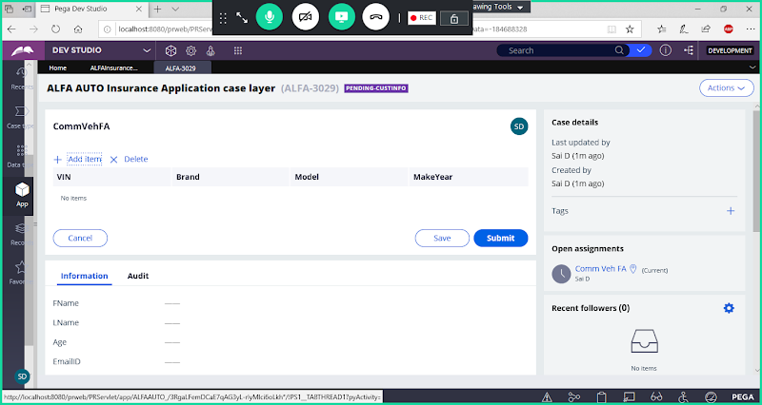

**Click on Add Item & Add Records**

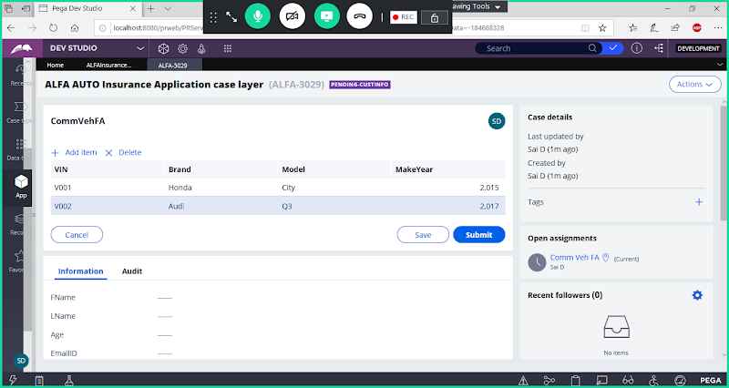

**Submit**

**Diff b/w Decision table & Decision Tree:**

**Decision Table:**

* **If, else if & Otherwise**
* **We can add Conditions with one column in table**
* **In Decision Table The properties involved in condition are constant for all the conditions being defined. N  number of conditions we have in every row all properties will be participating**
* **We have expression builder in Decision table**
* **In decision Table we cannot call other decision rules**
* **In Table complex logic is difficult to read**

**Decision Tree:**

* **if statements & Otherwise( Java Programming)**
* **We can add logic with one column with static records.**
* **In Decision Tree each row of condition can be defined using different properties**
* **We cannot use expression builder in Decision Tree. To Define Expressions for Decision Tree Properties we can Use Decision table to Add Expressions.**
* **In decision tree we can call other Decision Rules ( Decision table, Decision Tree, Map Value)**
* **In Tree complex logic is easy to read & understand**
* **If we add any Nested If ( Under If Statement If we add any sub Conditions then AND Logic will apply b/w one If Statement- For One If Statement we can specify one result)**

**What is procedure to call Decision Rules in Decision Tree:**

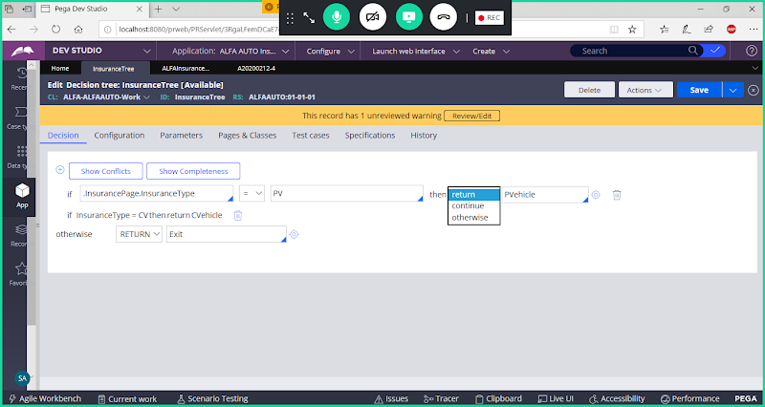

**To call other Decision rules do below setting-> Go to Configuration tab:**

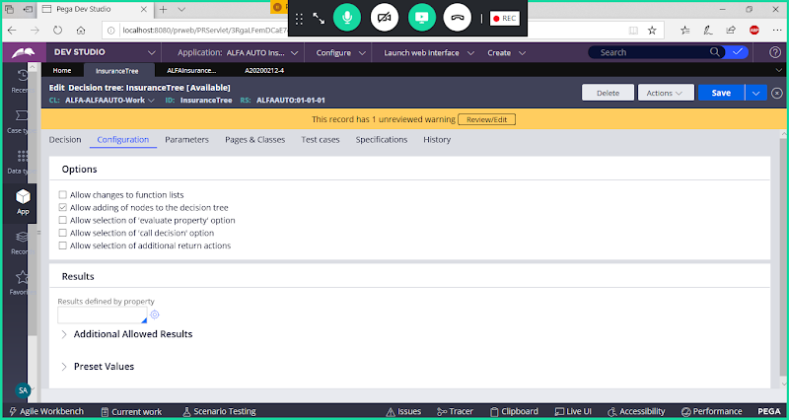

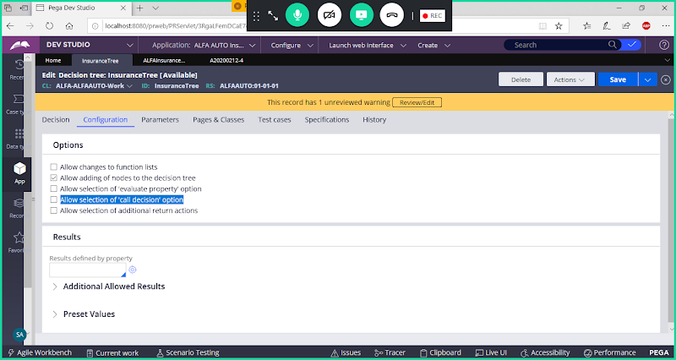

**Enable: Allow selection of call decision option**

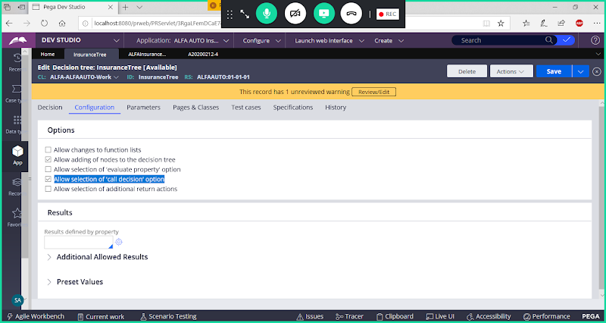

**Save Rule**



